Feature Descriptions
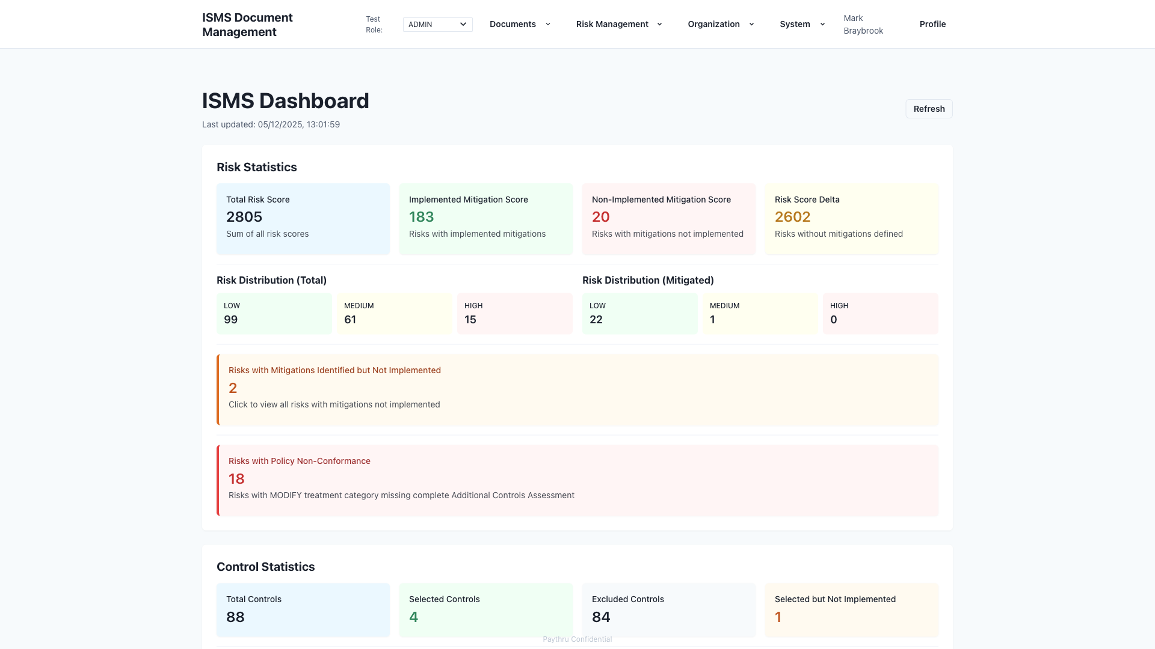
01 - Dashboard
The dashboard provides a real-time overview of your ISMS. Administrators and security managers use it to monitor risk scores, track control implementation, and identify documents needing review. It highlights overdue items and shows mitigation progress, helping prioritize work and maintain compliance.

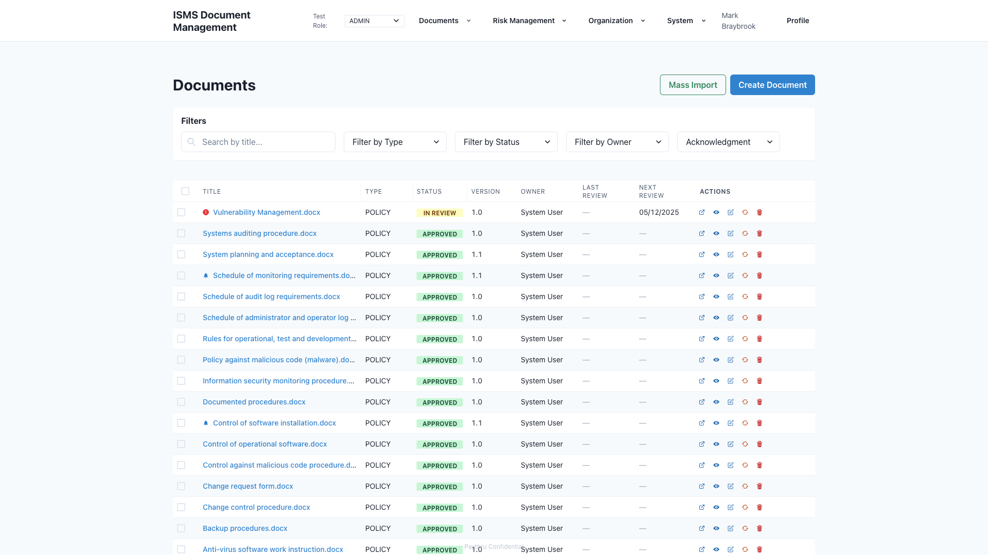
02 - Documents Library
The Documents Library is a central catalog of all ISMS documents. Administrators and editors manage policies, procedures, and records stored in SharePoint or Confluence, track versions, assign owners, and set review schedules. Staff can browse approved documents and access them directly from their source locations.

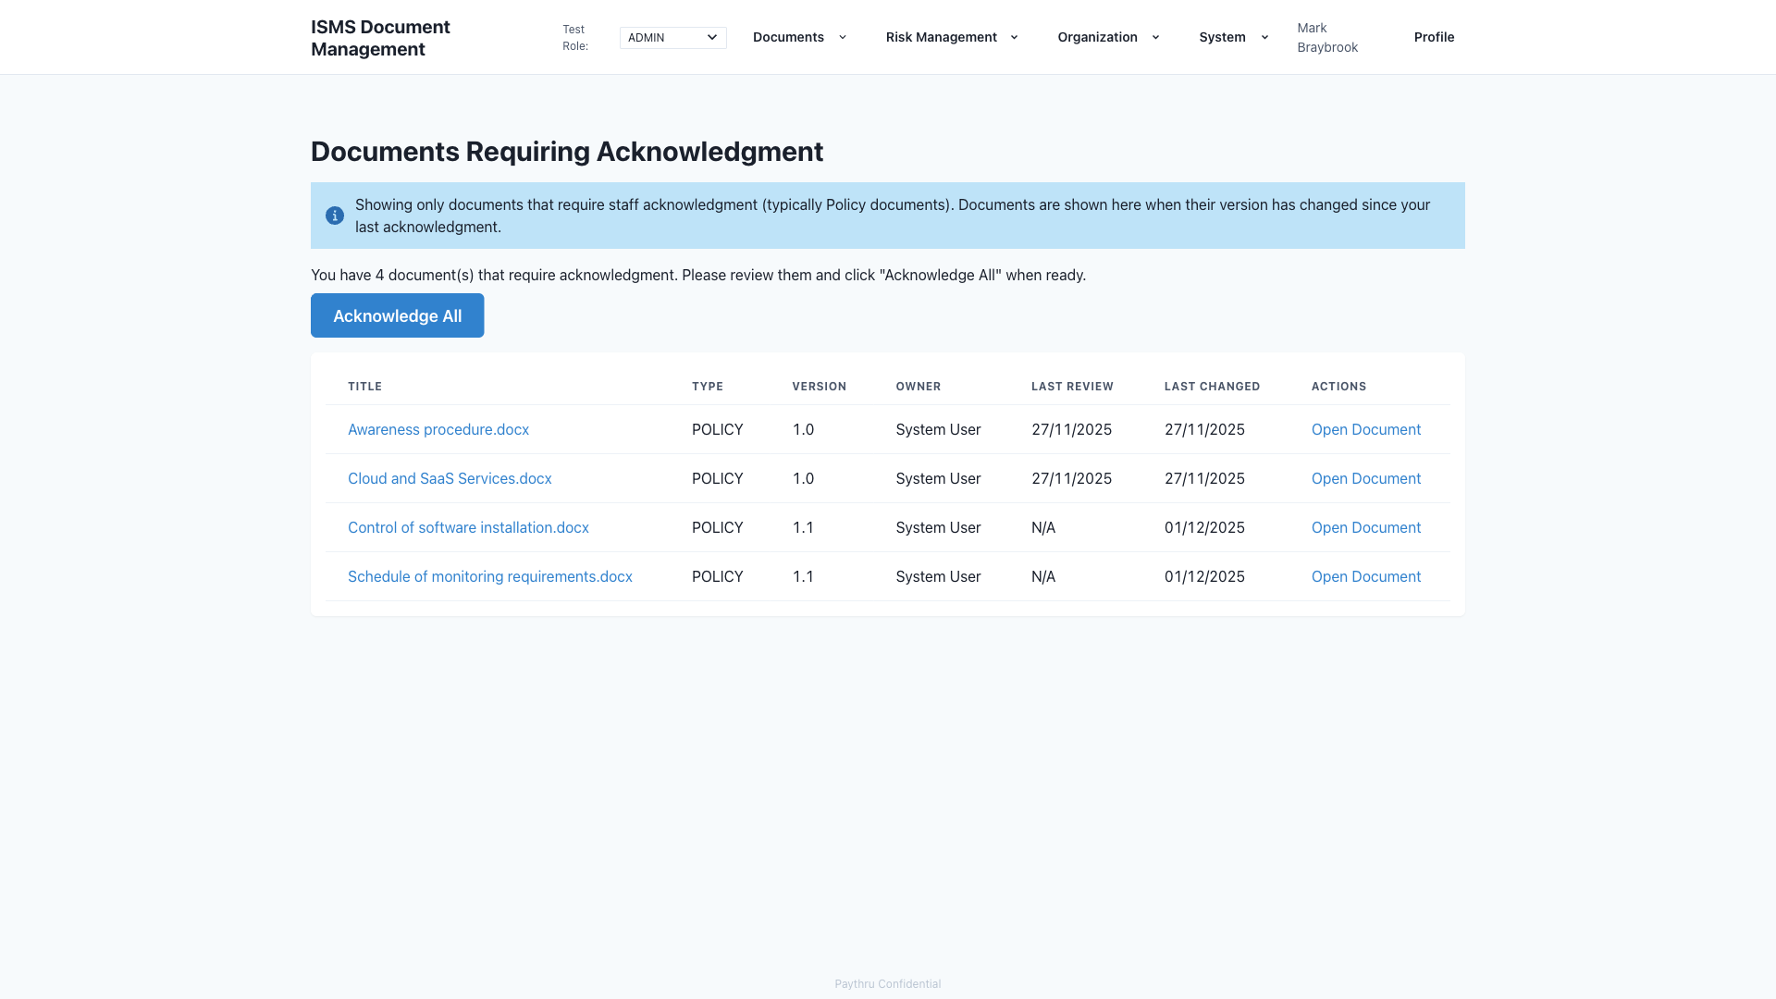
03 - Acknowledgments
The Acknowledgments feature ensures staff read and understand updated policies. When documents change, staff receive notifications and can acknowledge them individually or in bulk. Administrators can track completion, ensuring everyone stays current with policy updates.

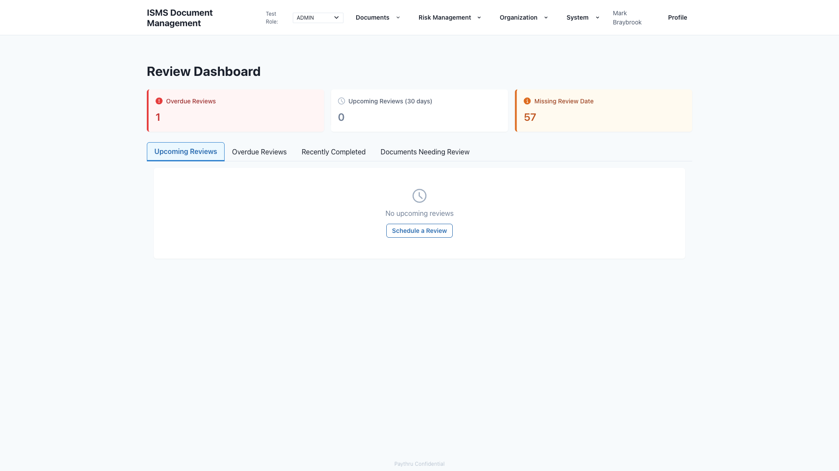
04 - Reviews
The Reviews page helps administrators manage document review cycles. It shows upcoming and overdue reviews, allows scheduling review tasks, and tracks completion. This keeps documents current and supports continuous improvement of the ISMS.

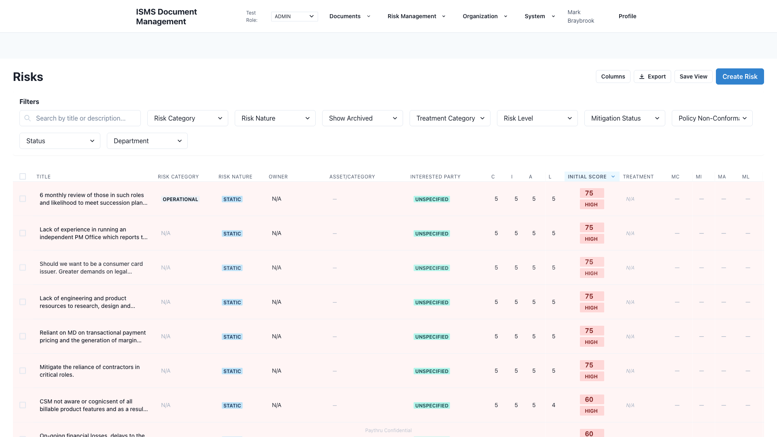
05 - Risk Register
The Risk Register is the central repository for all identified risks. Risk owners and administrators record risks with impact scores, treatment plans, and links to controls and assets. It supports risk assessment, tracks mitigation progress, and helps prioritize actions.

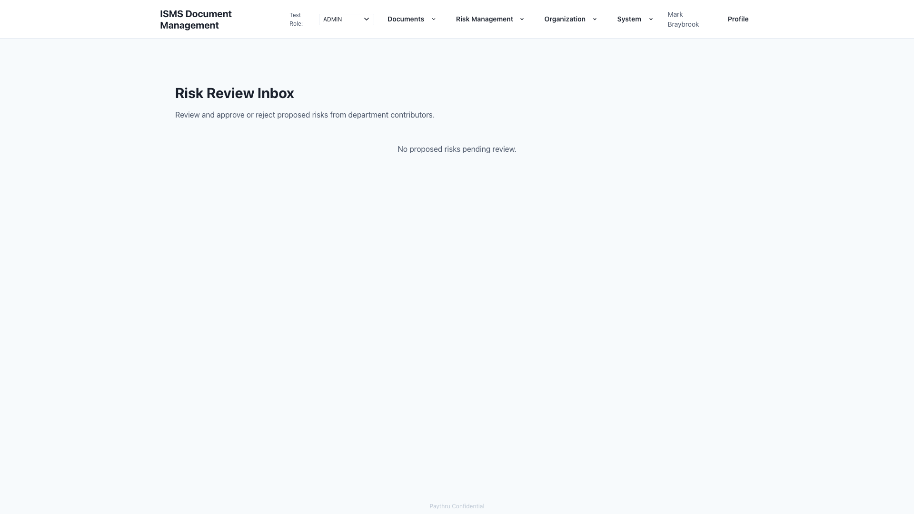
06 - Review Inbox
The Review Inbox is where administrators review and approve risks submitted by department contributors. It streamlines the approval workflow, allowing reviewers to accept, reject, or request changes before risks enter the register.

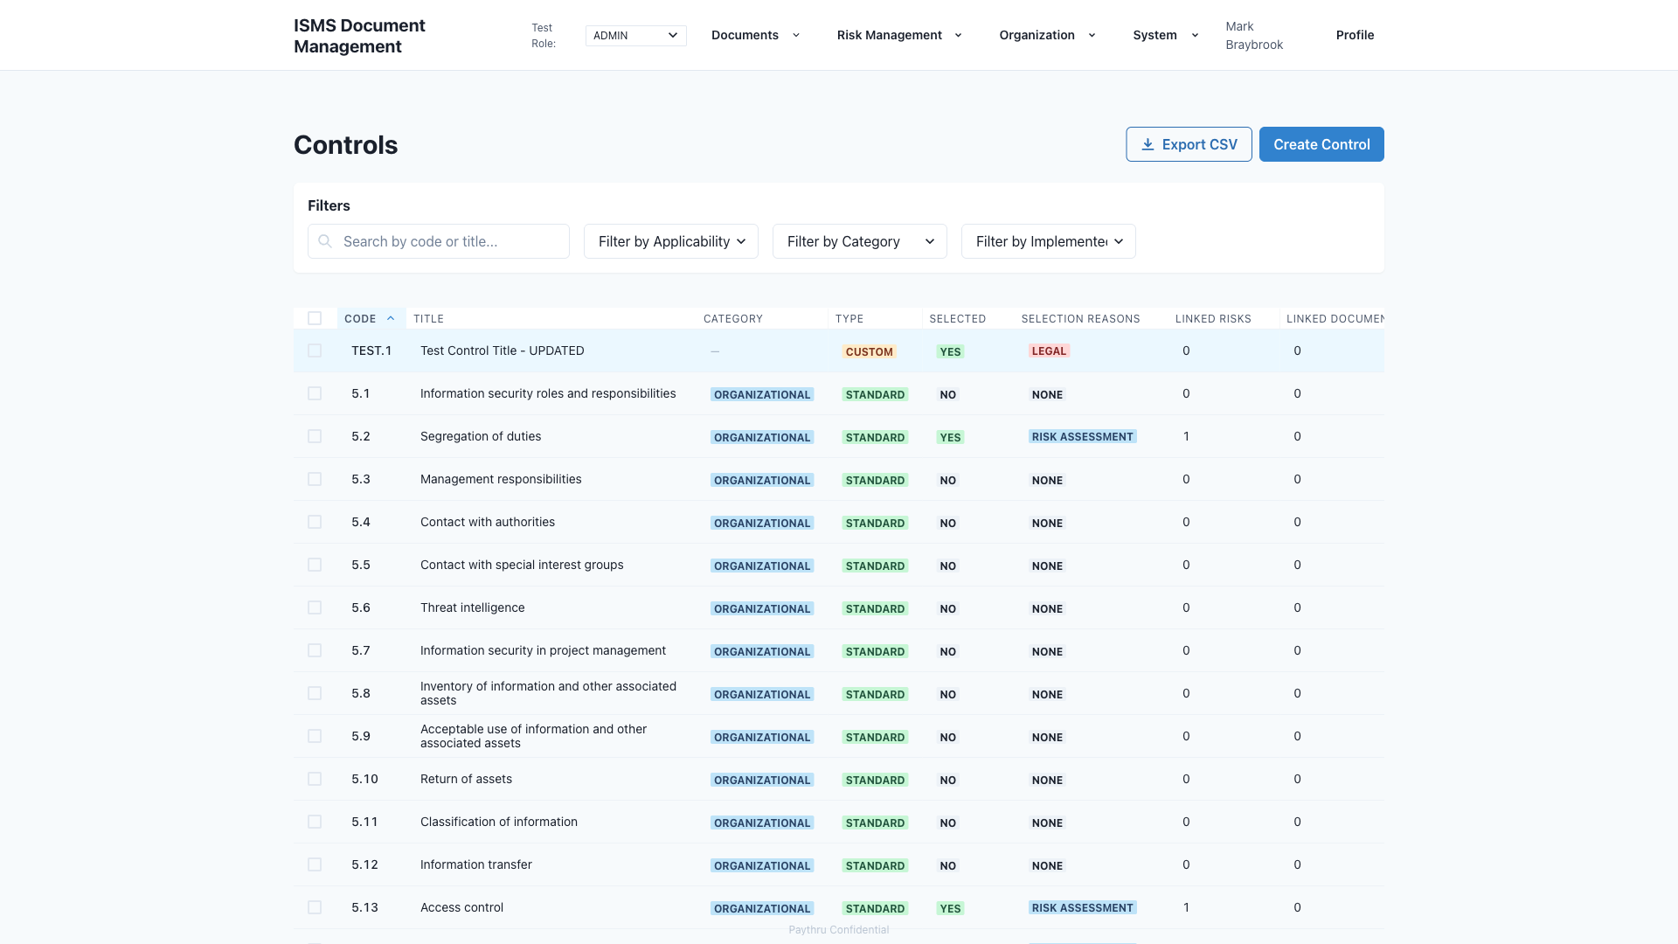
07 - Controls
The Controls page manages ISO 27001 Annex A controls. Administrators select applicable controls, document justifications, link them to risks and documents, and track implementation. This supports the Statement of Applicability and demonstrates control coverage.

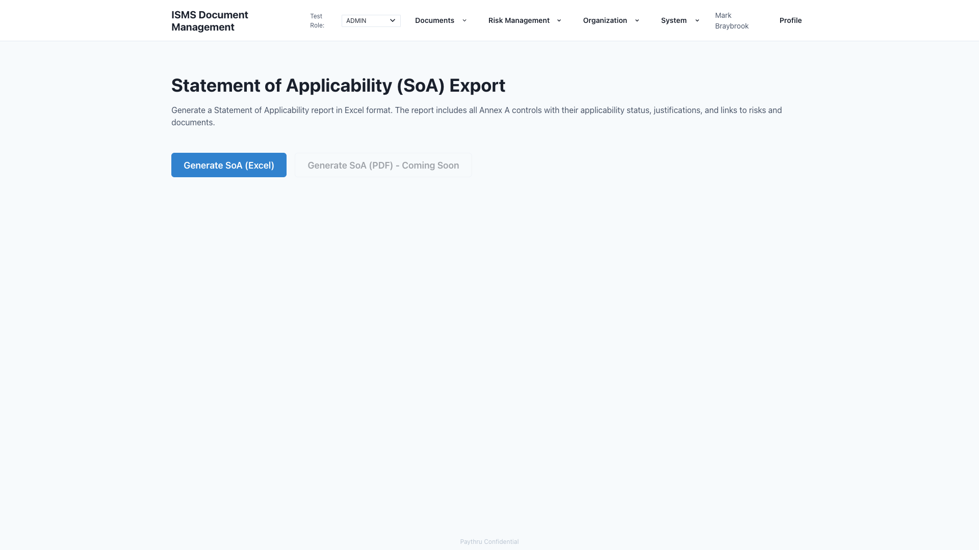
08 - Statement of Applicability (SoA)
The SoA feature generates the Statement of Applicability report required for ISO 27001 certification. Administrators export an Excel file listing all controls, their applicability, justifications, and links to risks and documents. This provides auditors with a clear view of your control framework.

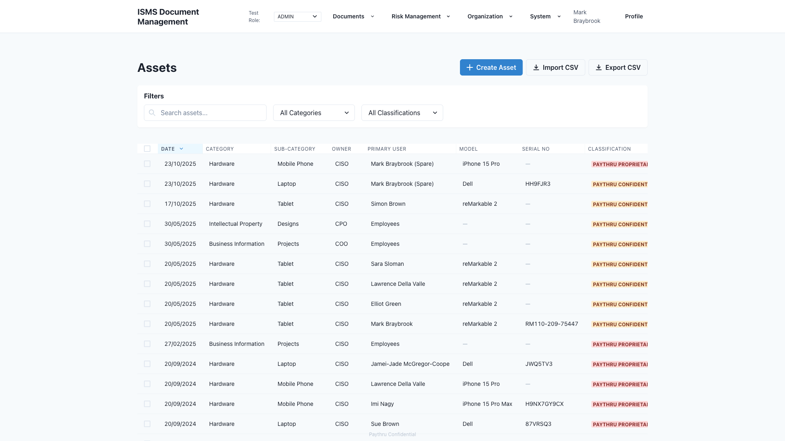
09 - Assets
The Assets page maintains an inventory of information assets. Administrators record hardware, software, and infrastructure with details like classification, owner, and location. Assets can be linked to risks, helping identify what needs protection.

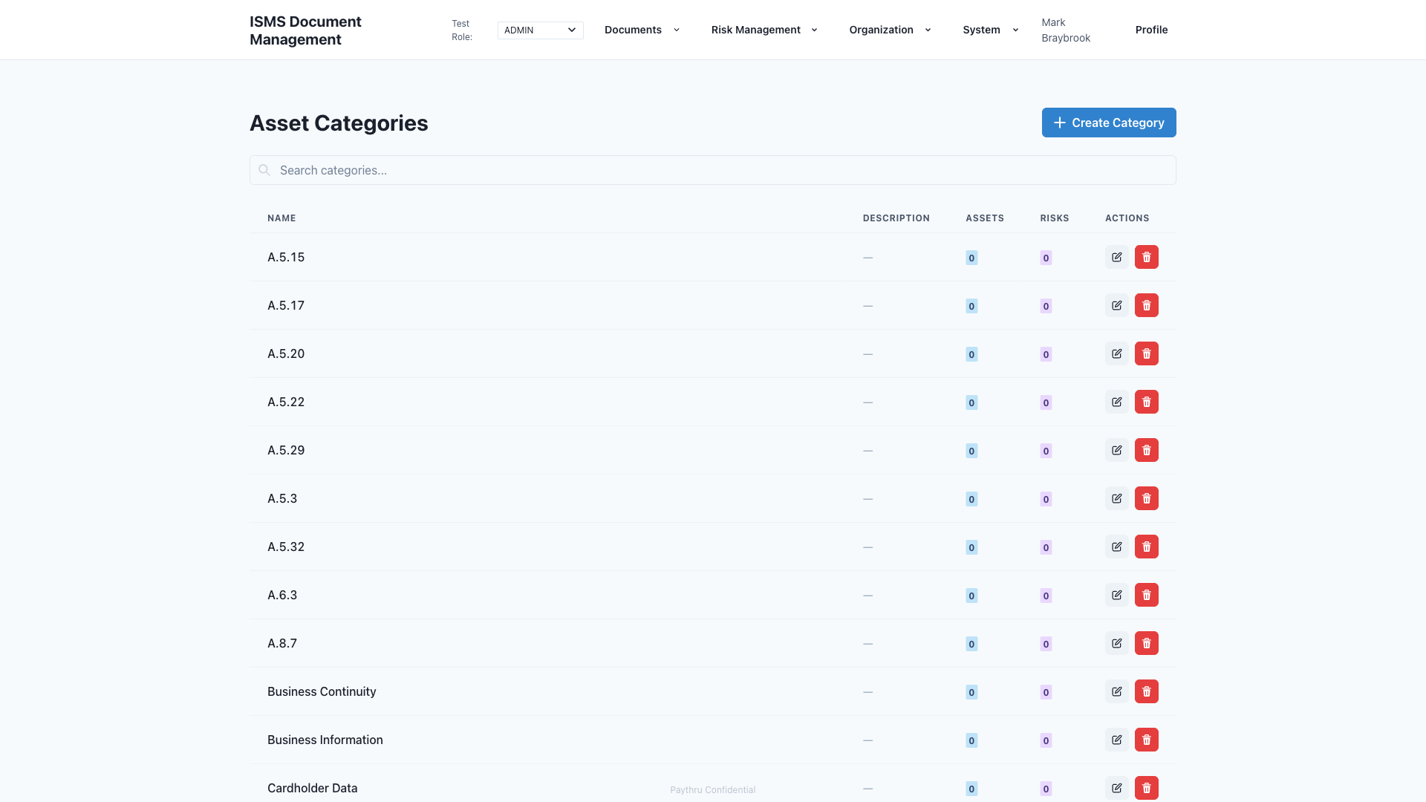
10 - Asset Categories
Asset Categories organize assets into logical groups (e.g., Hardware, Software, Infrastructure). Administrators use categories to classify assets consistently and filter the asset register, making it easier to manage large inventories.

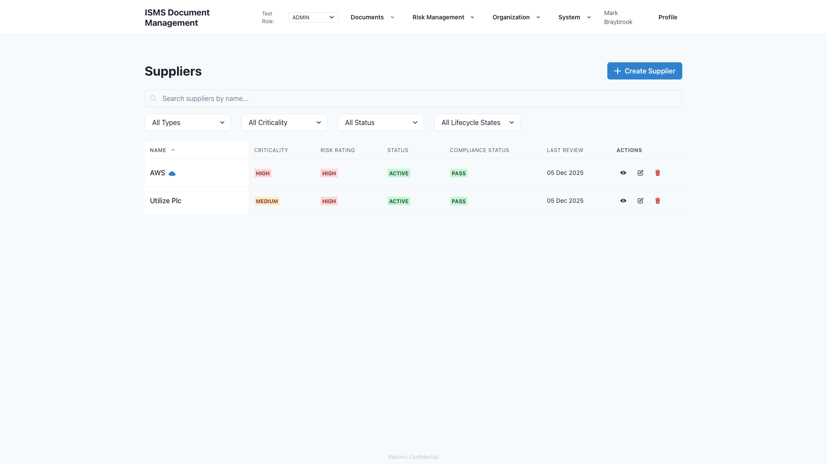
11 - Suppliers
The Suppliers page manages third-party vendor relationships and their security posture. Administrators track supplier assessments, compliance status, contracts, and review schedules. This helps ensure suppliers meet security requirements and supports due diligence.

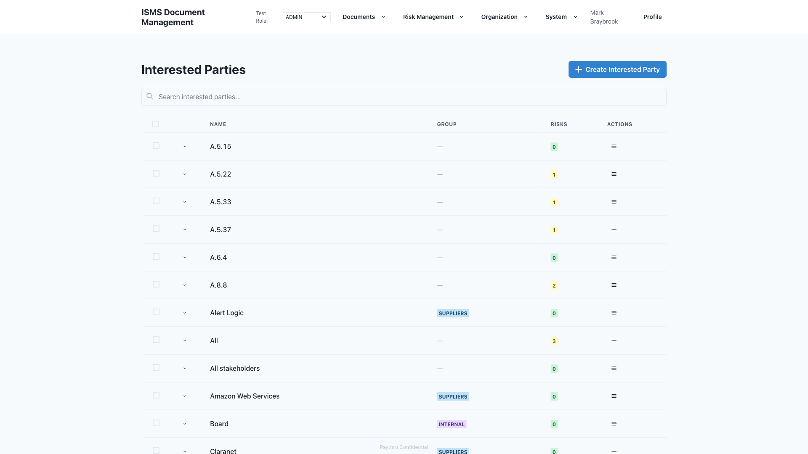
12 - Interested Parties
The Interested Parties page identifies stakeholders with requirements that affect the ISMS. Administrators document parties like customers, regulators, and partners, their requirements, and how they’re addressed. This supports ISO 27001 requirements for understanding stakeholder needs.

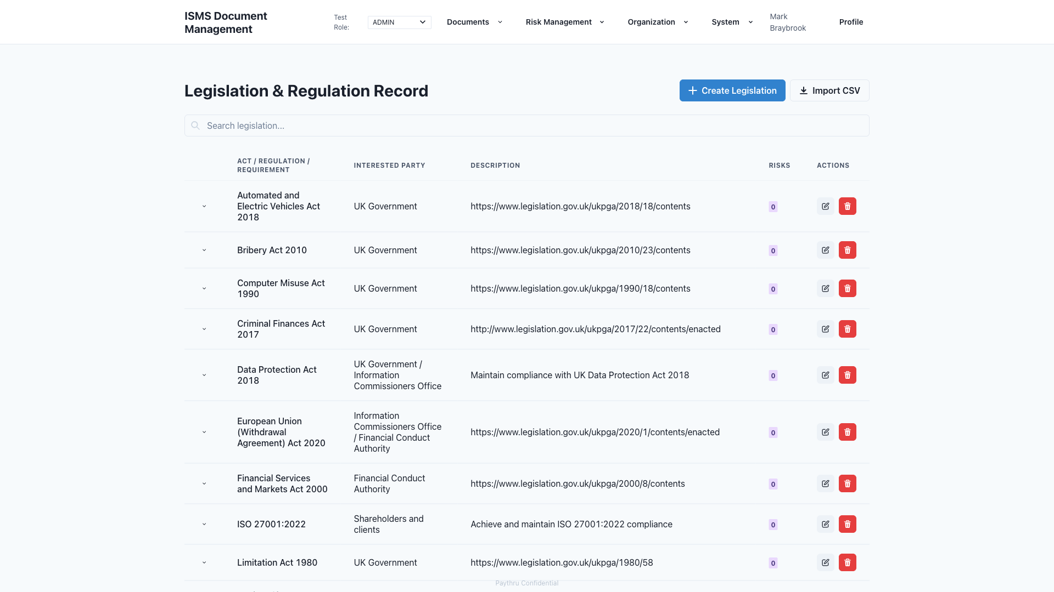
13 - Legislation
The Legislation page tracks legal and regulatory requirements. Administrators record applicable laws and regulations, link them to risks, and document compliance approaches. This helps ensure legal obligations are identified and addressed.

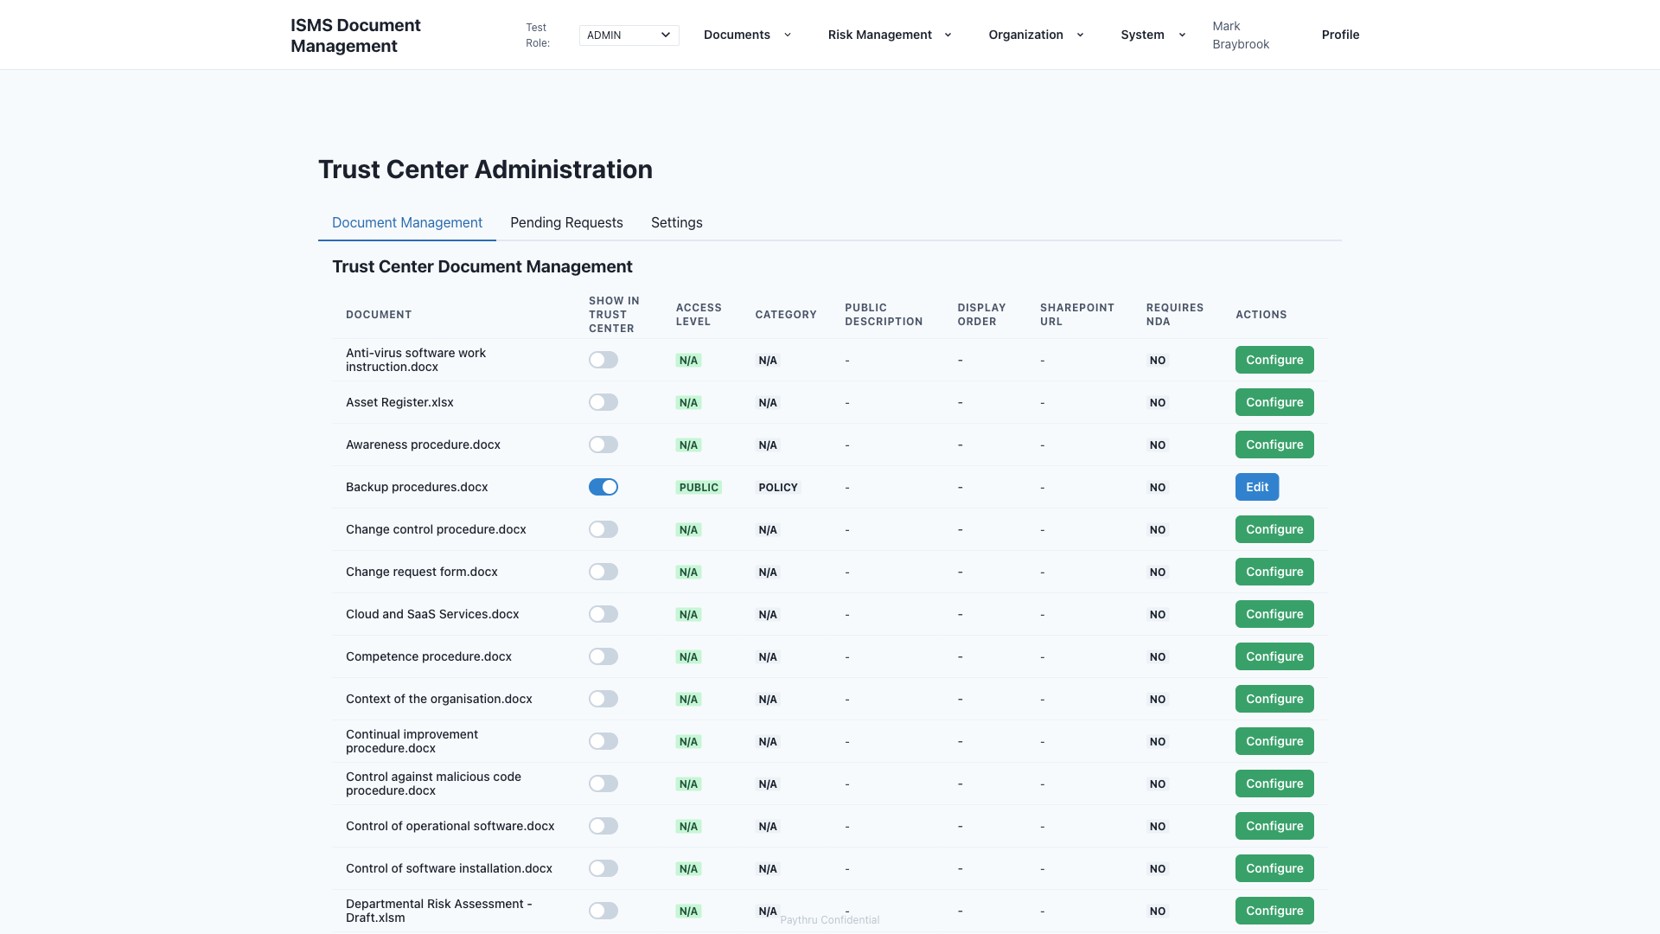
14 - Trust Center
The Trust Center is a public-facing portal where external parties can access security documentation. External users can register, request access, and download approved documents like certifications and policies. Administrators control visibility and manage access requests, supporting transparency and customer trust.

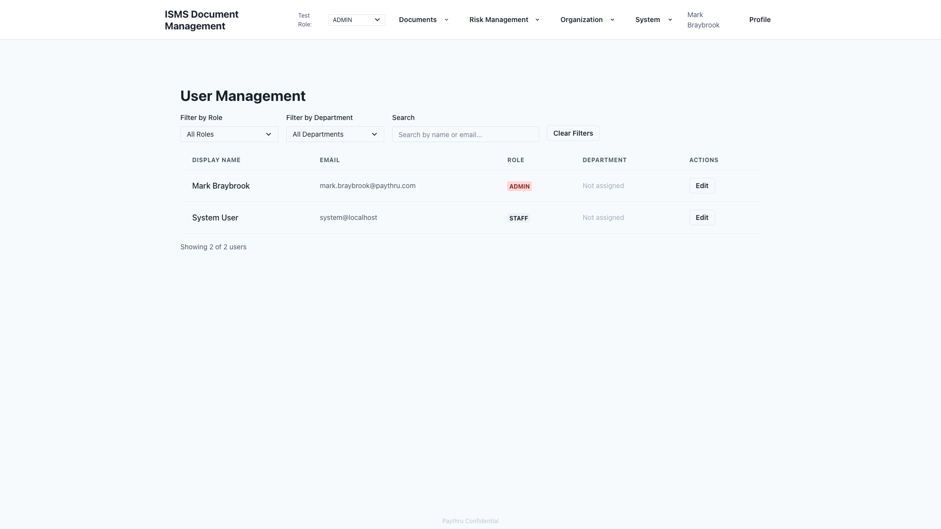
15 - User Management
User Management allows administrators to control system access and permissions. Administrators assign roles (Admin, Editor, Staff, Contributor), set departments, and manage user accounts. This ensures the right people have appropriate access to ISMS functions.

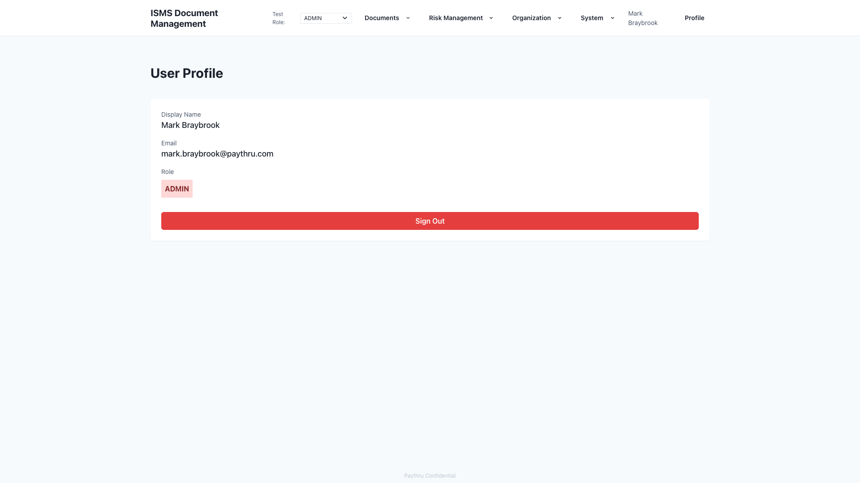
16 - Profile
The Profile page lets users view their account information, role, and department. All users can see their permissions and sign out. This provides transparency about access and helps users understand their responsibilities in the system.

